Ideation Phase
Define the Problem Statements

Date | 02 November 2025
Team ID | NM2025TMID07661
Project Name | Streamlining Ticket Assignment for Efficient Support Operations
Maximum Marks | 2 Marks

Customer Problem Statement Template:
I am a support team manager responsible for assigning customer support tickets to agents.I’m trying to improve the speed and accuracy of ticket distribution so that customer issues are resolved faster.But the current manual ticket assignment process is slow, inefficient, and often inaccurate.Because there is no automated system that categorizes and assigns tickets based on priority, expertise, or workload.Which makes me feel frustrated and overwhelmed, as it leads to delays, reduced productivity, and lower customer satisfaction.
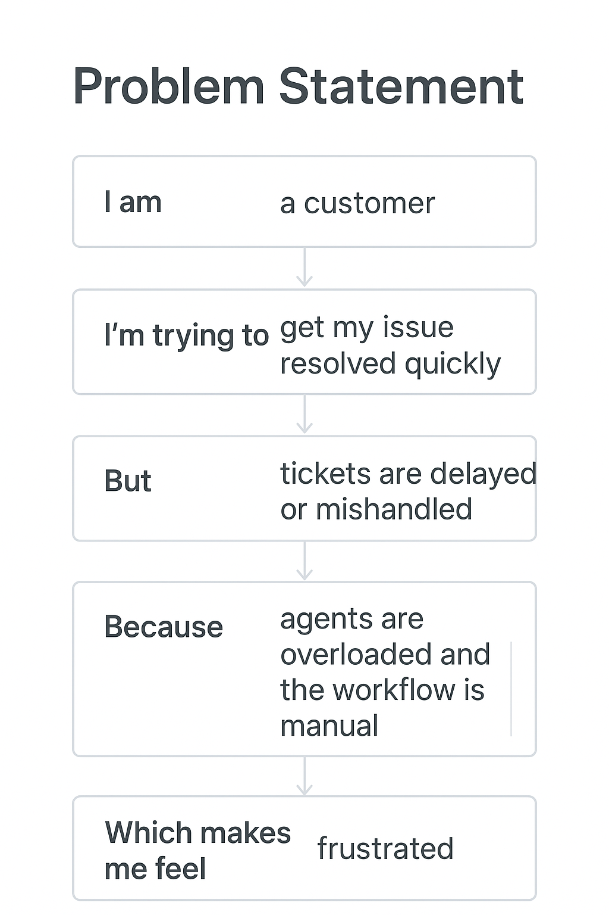
Reference:https://miro.com/templates/customer-problem-statement/
Example:

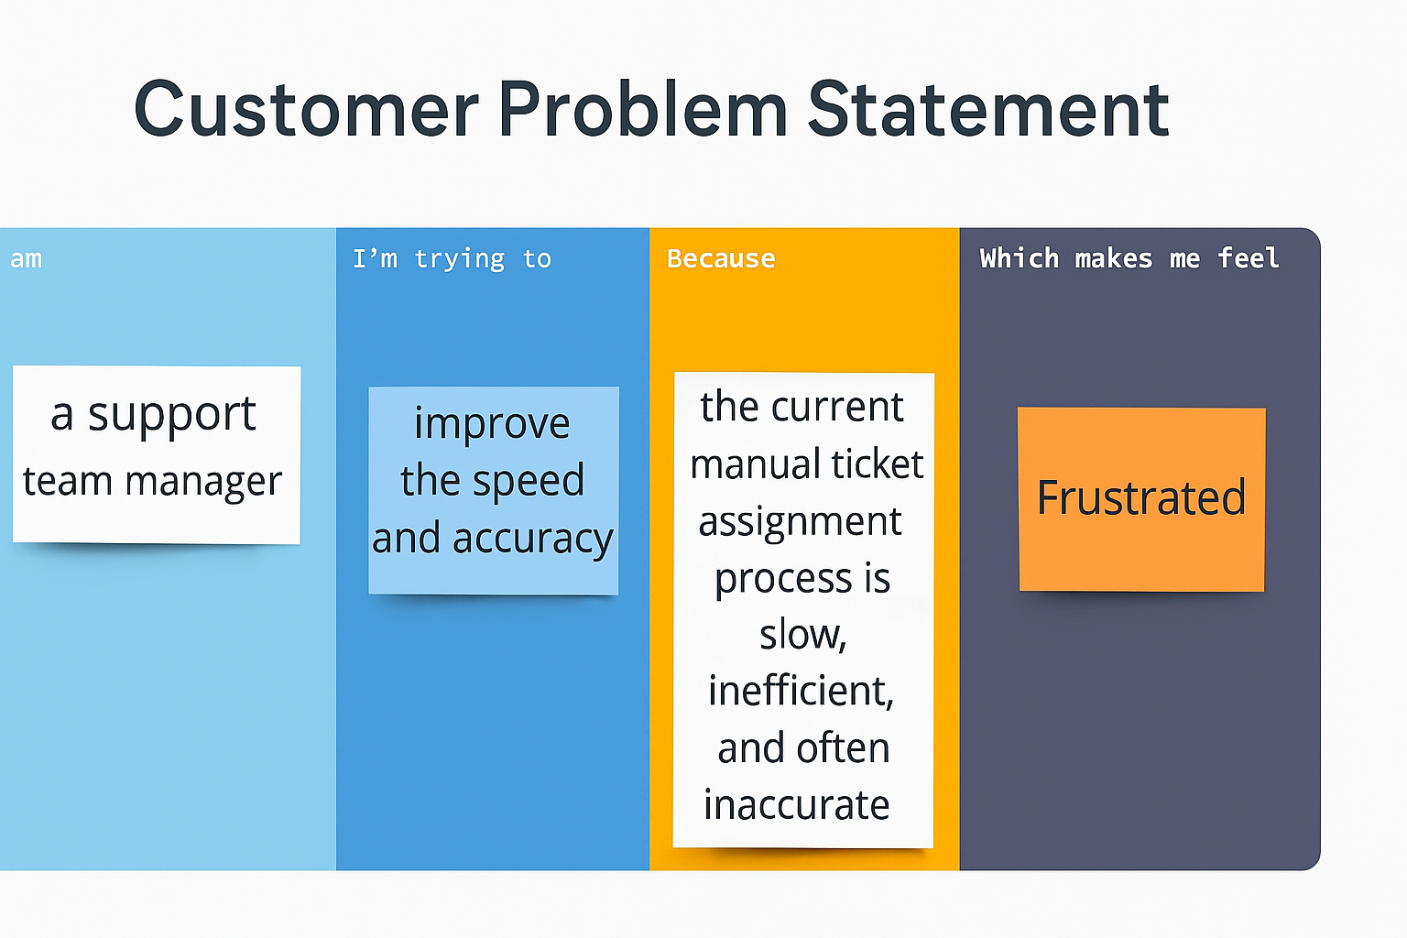

Problem Statement

Problem Statement | I am (Customer) | I’m trying to | But | Because | Which makes me feel
PS–1 | A support team manager responsible for overseeing multiple customer support agents. | Ensure that incoming customer tickets are assigned to the right agents quickly and based on their skill set or workload. | The current manual ticket assignment process is inefficient and causes delays in response and resolution times. | There is no automated system to categorize, prioritize, and route tickets effectively. | Overwhelmed and frustrated, as customer satisfaction drops due to slow and inconsistent ticket handling.
PS–2 | A customer service agent handling multiple support tickets daily. | Focus on resolving customer issues efficiently without wasting time searching for tickets relevant to my expertise. | Tickets are randomly assigned, leading to mismatches between my skills and the assigned issues. | The system lacks an intelligent ticket distribution mechanism that considers agent specialization and workload. | Unproductive and demotivated, as I spend more time managing tickets than solving customer problems.

